

DEDAN KIMATHI UNIVERSITY OF TECHNOLOGY

SCHOOL OF ENGINEERING

DEPARTMENT OF ELECTRICAL & ELECTRONIC ENGINEERING

COURSE:
IoT-Enabled Automatic Recharge System for Kenyan Prepaid Meters Based on Advanced Metering Infrastructure

Supervisor:
Mr. NDEGWA

Presented by:
NAME: MOSES MAINGI REG NO: E021-01-1297/2021

NAME: Kelvin Limo REG NO: E021-01-1302/2021

NAME: DANIEL KIMOI REG NO: E021-01-1318/2021

A project proposal submitted in partial fulfillment of the requirement for the award of the
Degree of Bachelor of Science in Electrical and Electronic Engineering in the Dedan Kimathi University of Technology
JULY 2025

DECLARATION
This research proposal is my (our) original work, except where due acknowledgment is made in the text, and to the best of my (our) knowledge has not been previously submitted to Dedan Kimathi University of Technology or any other institution for the award of a degree or diploma.

Name: Moses Maingi |  | Reg No: E021-01-1297/2021
Signature: ............................................ |  | Date: ......................................
Name: Kelvin Limo |  | Reg No: E021-01-1302/2021
Signature: ............................................. |  | Date: ......................................
Name: Daniel Kimoi |  | Reg No: E021-01-1318/2021
Signature: ............................................. |  | Date: ......................................

SUPERVISOR CONFIRMATION
This research proposal has been submitted to the Department of Electrical and Electronic
Engineering, Dedan Kimathi University of Technology, with my approval as the supervisor:

Name: Mr. Ndegwa
Signature: ....................................... Date: ......................................

Table of Contents
Chapter 1 : Introduction 1
1.1 Background 1
1.2 Problem Statement 1
1.3 Justification 2
1.4 Objectives 3
1.4.1 Main Objective 3
1.4.2 Specific Objective 3
1.5 Scope of Study 3
Chapter 2 : Literature Review 5
2.1 Introduction 5
2.2 Advanced Metering Infrastructure (AMI) Overview 6
2.3 Background of Prepaid Metering in Kenya 8
2.4 Evolution of Prepaid Metering Systems 8
2.4.1 Traditional Prepaid Systems 8
2.4.2 GSM-Based Prepaid Meters 8
2.4.3 Early IoT-Based Prototypes and Smart Meters 9
2.5 The Role of Mobile Money in Kenya (M-Pesa) 10
Chapter 3 : Methodology 11
3.1 Design and Prototyping of ESP32-Based Prepaid Meter 11
3.1.1 Circuit Design and Component Assembly 11
3.1.2 ESP32 Firmware Development 12
3.2 Development of Cloud Backend and M-Pesa Simulation 13
3.2.1 Cloud Backend Design 13
3.2.2 M-Pesa Daraja API Simulation 14
3.3 System Validation and Testing 15
3.3.1 Integration Testing 15
3.3.2 Performance and Security Testing 16
Chapter 4 : Expected Outcomes and Contributions 18
Contributions to Knowledge and Practice 18
Significance of the Study 19
References 21
APPENDICES 22
Project Timeline (Preliminary) 22

List of Figures

Figure 1: Understanding Advanced Metering Infrastructure (AMI) 11
Figure 2: Communication Workflow in an Advanced Metering Infrastructure (AMI) System 11
Figure 3: Functional Block Diagram of the ESP32-Based Control System 16
Figure 4: Cloud-Based Token Purchase and M-Pesa Simulation Architecture 18
Figure 5: Block Diagram of the ESP32-Based Smart Metering System 21

Abstract
The project titled "IoT-Enabled Automatic Recharge System for Kenyan Prepaid Meters Based on Advanced Metering Infrastructure" aims to modernize the electricity top-up process by eliminating the need for manual token entry. In many Kenyan homes, especially in residential areas, Customer Interface Units (CIUs) are either missing or faulty, making it difficult for users to recharge their meters. Manual input is also prone to errors and delays—causing unnecessary downtime and service interruptions. This system automatically processes simulated mobile payments and delivers recharge tokens directly to a smart meter, improving speed, accuracy, and user experience. It ensures uninterrupted electricity by preventing credit depletion and enables real-time, digital communication that bypasses SMS-related failures. Additionally, the solution reduces support and infrastructure costs, enhances customer satisfaction, and is scalable across Kenya’s existing smart grid setup. Its design aligns with the country’s shift toward Advanced Metering Infrastructure (AMI), making it both highly relevant and nationally deployable.

Introduction

Background
Kenya’s energy sector has seen significant advancements, particularly with the adoption of prepaid electricity meters. These meters empower consumers by allowing them to manage their electricity consumption and expenditure more effectively. However, the current prepaid metering system, while beneficial, presents several challenges, especially concerning the manual recharge process. Consumers often face inconveniences such as the need for manual token entry, which can be prone to errors and delays. Furthermore, the reliance on Customer Interface Units (CIUs) and SMS-based token delivery introduces vulnerabilities like device unavailability, power outages affecting CIU functionality, and message delivery delays.
This research proposes the development of an IoT-enabled automatic recharge system for Kenyan prepaid meters, leveraging Advanced Metering Infrastructure (AMI). The proposed system aims to address the existing limitations by providing a seamless, automated, and efficient solution for electricity top-ups. By integrating with Kenya’s dominant mobile payment platform, M-Pesa, and employing real-time communication capabilities of AMI, this system will eliminate manual interventions, reduce service disruptions, and enhance the overall customer experience. This initiative aligns with the national digital transformation agenda and the ongoing shift towards smarter grid technologies, promising a more reliable and user-friendly energy management ecosystem for Kenyan households.

Problem Statement
The current prepaid electricity metering system in Kenya, despite its advantages in promoting energy management, is plagued by several critical issues that lead to consumer dissatisfaction and operational inefficiencies. These problems primarily stem from the manual and often unreliable methods of recharging and token management:
- Dependence on Manual Token Entry and Faulty CIUs: Many Kenyan households, particularly in residential areas, either lack functional Customer Interface Units (CIUs) or find them difficult to use. This necessitates manual input of long token codes, a process that is not only cumbersome but also highly susceptible to human error, leading to failed recharges and prolonged power outages.
- Lack of Seamless Integration with Dominant Mobile Payment Platforms: While mobile money platforms like M-Pesa are widely used for various transactions in Kenya, existing prepaid meter systems, especially older GSM-based ones, do not offer direct, automated integration for recharges. This forces users to manually initiate payments and then separately enter tokens, creating a disjointed and inefficient user experience.
- Vulnerability to Communication Delays and Failures: The reliance on SMS for token delivery introduces significant vulnerabilities. Users frequently experience delays in receiving tokens or, in some cases, complete message delivery failures. Such communication breakdowns directly translate to unexpected power disconnections and considerable inconvenience.
- Absence of Advanced Metering Infrastructure (AMI) Utilization: Most existing systems do not fully leverage the capabilities of Advanced Metering Infrastructure (AMI). AMI enables two-way communication between the utility and the meter, facilitating real-time monitoring, remote control, and automated data exchange. The lack of AMI integration in current systems limits efficient load control, real-time balance monitoring, and proactive service management.
- Cost and Complexity Barriers: Many proposed or existing IoT-based prototypes are often complex and expensive to implement, hindering their widespread adoption and scalability in a cost-sensitive market like Kenya. There is a need for an affordable and robust solution that can be easily deployed across a large consumer base.
These challenges collectively result in frequent service interruptions, increased operational costs for utility providers due to support inquiries and field visits, and a diminished quality of service for consumers. There is a clear and urgent need for an innovative solution that automates the recharge process, integrates seamlessly with local payment ecosystems, utilizes advanced metering technologies, and remains cost-effective for national deployment.

Justification
The project is justified on technological, economic, social, and environmental grounds. It addresses the pressing challenges in Kenya’s current prepaid electricity system by proposing an IoT-enabled automatic recharge solution.
- Technologically, it uses cost-effective components like the ESP32 and integrates with a simulated M-Pesa API to demonstrate advanced smart metering and automation within an IoT ecosystem.
- Economically, it lowers hidden consumer costs (e.g., time, service disruptions) and helps KPLC reduce operational expenses, making it a financially attractive and scalable solution.
- Socially, it improves the quality of life by ensuring reliable electricity access, especially for households and small businesses, and enhances consumer control over energy use.
- Environmentally, it supports energy conservation through real-time usage feedback and reduces reliance on paper-based or manual processes.

Objectives

Main Objective

- To design, develop, and evaluate an IoT-enabled automatic recharge system for Kenyan prepaid meters based on Advanced Metering Infrastructure (AMI) principles.

Specific Objective
- To design and prototype a simulated prepaid meter using the ESP32 microcontroller, including load control, balance monitoring, and display modules.
- To develop and integrate a cloud-based backend and M-Pesa Daraja API simulation for automated recharge processing and communication with the ESP32 prototype.
- To validate the functionality and performance of the integrated system through comprehensive testing, including recharge automation, load control, and security measures.

Scope of Study
This research project focuses on the development of a proof-of-concept prototype for an IoT-enabled automatic recharge system for Kenyan prepaid meters. The scope of the project is defined by the following key aspects:
- Meter Simulation: The project will utilize an ESP32 microcontroller to simulate the functionality of a prepaid electricity meter, including energy consumption, balance decrement, and token application. This simulation will allow for comprehensive testing of the automatic recharge logic without requiring access to actual KPLC meters.
- M-Pesa Daraja API Simulation: To facilitate testing of the payment integration, a simulated M-Pesa Daraja API will be developed. This simulation will mimic the behavior of the actual Daraja API, specifically its C2B (Customer to Business) payment functionalities and callback mechanisms, enabling the system to receive simulated payment confirmations and trigger recharges.
- Automatic Recharge Mechanism: The core functionality of the system will be the automated processing of simulated M-Pesa payments and the subsequent application of recharge tokens to the simulated meter balance, eliminating the need for manual token entry.
- Real-time Balance Monitoring and Load Control: The system will implement real-time monitoring of the simulated meter balance and will incorporate a load control mechanism (using a relay) to simulate power disconnection upon zero balance and reconnection upon successful recharge.
- Hardware Prototype: A physical prototype will be constructed using an ESP32 development board and essential peripherals (relay, LCD/OLED, LEDs, buzzer) to demonstrate the system’s functionality.
- Cloud-based Backend: A cloud platform will be set up to manage data flow, process recharge requests, and serve as the central communication hub between the simulated meter and the payment gateway.
- Focus on Technical Feasibility: The primary focus of this research is to demonstrate the technical feasibility and effectiveness of the proposed automated recharge solution. While scalability and cost-effectiveness will be considered in the design, a full-scale commercial deployment and regulatory compliance are beyond the immediate scope of this prototype project.
Exclusions: This project will not involve direct integration with KPLC’s live metering infrastructure or actual M-Pesa transactions. The system will operate in a simulated environment for testing and demonstration purposes. Furthermore, detailed analysis of specific security vulnerabilities beyond standard best practices for IoT communication will be considered for future work.

Literature Review

Introduction
The concept of prepaid metering has evolved significantly, moving from traditional mechanical meters to advanced smart meters with integrated communication capabilities. Early prepaid systems often relied on physical tokens or smart cards, which, while offering some control to consumers, still required manual intervention for recharges [1]. The advent of GSM-based prepaid meters marked a step forward by enabling remote token delivery via SMS. However, as highlighted in the problem statement, these systems often lack seamless integration with modern mobile payment platforms and are susceptible to communication delays and failures inherent in SMS-based systems.
Recent advancements in the Internet of Things (IoT) have paved the way for more sophisticated prepaid metering solutions. IoT-enabled smart meters offer real-time data collection, remote monitoring, and control capabilities. Several research papers and prototypes have explored the use of IoT for energy management, including prepaid metering [6]. For instance, studies have demonstrated IoT-based systems that monitor energy consumption and provide alerts for low balances, with some even incorporating basic online recharge functionalities. These systems often utilize microcontrollers like ESP32 or NodeMCU for connectivity and data transmission over Wi-Fi or other wireless protocols [4].
However, a critical gap exists in the comprehensive integration of these IoT capabilities with local mobile payment ecosystems, particularly in regions like Kenya where mobile money platforms like M-Pesa are dominant [5]. While some systems propose online payment integration, they often do not detail direct, automated recharge mechanisms that bypass manual token entry. Furthermore, many existing IoT solutions, while technically sound, may not be cost-effective or scalable for widespread deployment in developing economies. The complexity of integrating various components and the cost of specialized hardware can be significant barriers.
Moreover, the full potential of Advanced Metering Infrastructure (AMI) is often underutilized in existing prepaid meter implementations. AMI facilitates two-way communication, enabling not just data collection from the meter but also remote commands to the meter, such as load control and firmware updates. This two-way communication is crucial for efficient grid management and enhanced customer service. Many current systems, even those with IoT capabilities, primarily focus on one-way data transmission, limiting their ability to provide real-time load control or proactive service management.
In the Kenyan context, while there are various types of electricity meters, including some smart meters, the specific challenge of integrating automatic M-Pesa recharges and fully leveraging AMI for seamless, manual-input-free operation remains largely unaddressed by existing commercial solutions. The proposed system aims to bridge these gaps by developing a cost-effective, ESP32-based solution that not only integrates seamlessly with M-Pesa for automated recharges but also fully utilizes AMI principles for real-time monitoring and load control, offering a truly advanced and user-centric prepaid metering experience.

Advanced Metering Infrastructure (AMI) Overview
Advanced Metering Infrastructure (AMI) represents a significant evolution from traditional one-way metering systems to a comprehensive, two-way communication network between utility providers and their customers [2]. Unlike Automatic Meter Reading (AMR) systems, which primarily focus on automated data collection, AMI enables a bidirectional flow of information, facilitating real-time monitoring, remote control, and enhanced grid management capabilities. The core components of an AMI system typically include:
- Smart Meters: These are advanced electronic meters installed at customer premises that accurately measure electricity consumption (and sometimes generation). Beyond basic measurement, smart meters are equipped with communication modules that allow them to send consumption data to the utility and receive commands from the utility in return. They can store data, detect outages, and in some cases, support remote connect/disconnect functionalities.
- Communication Network: This is the backbone of the AMI system, enabling data exchange between smart meters and the utility’s central system. Various communication technologies can be employed, including Power Line Carrier (PLC), cellular (GSM/GPRS/LTE), Wi-Fi, Radio Frequency (RF) mesh networks, and fiber optics. The choice of technology depends on factors such as geographical coverage, data rates, reliability, and cost. For a system like the proposed one, cellular communication (e.g., GPRS/LTE via an ESP32 with a SIM module) would be highly relevant for widespread deployment in Kenya [3].
- Data Concentrators/Collectors: These devices act as intermediaries in the communication network, collecting data from a group of smart meters and forwarding it to the Meter Data Management System (MDMS). They can also receive commands from the MDMS and relay them to individual meters. Concentrators are crucial for aggregating data, reducing network traffic, and ensuring efficient data flow.
- Meter Data Management System (MDMS): This is the central repository and processing unit for all meter data collected from the AMI network. The MDMS validates, cleans, and stores the vast amounts of data received from smart meters. It provides analytical capabilities, generates reports, and integrates with other utility systems such as billing, customer information systems (CIS), and outage management systems (OMS). The MDMS is essential for transforming raw meter data into actionable insights for utility operations and customer service.
- Head-End System (HES): The HES is the software application that manages the communication with the smart meters and data concentrators. It initiates data requests, sends commands to meters (e.g., remote connect/disconnect, tariff changes), and handles the initial processing of meter data before it is passed to the MDMS. The HES acts as the primary interface between the utility’s operational systems and the AMI network.
- Customer Portal/Interfaces: AMI systems often include customer-facing platforms that allow consumers to access their energy consumption data, view billing information, and manage their accounts. These interfaces can be web-based portals or mobile applications, empowering customers with greater control and transparency over their energy usage.
The proposed IoT-enabled automatic recharge system will integrate seamlessly within this AMI framework. While existing prepaid meters in Kenya may not fully utilize all AMI capabilities, our system will simulate and leverage key aspects, particularly the two-way communication for real-time balance monitoring and remote load control, and integrate with the payment gateway that would typically interact with the MDMS. 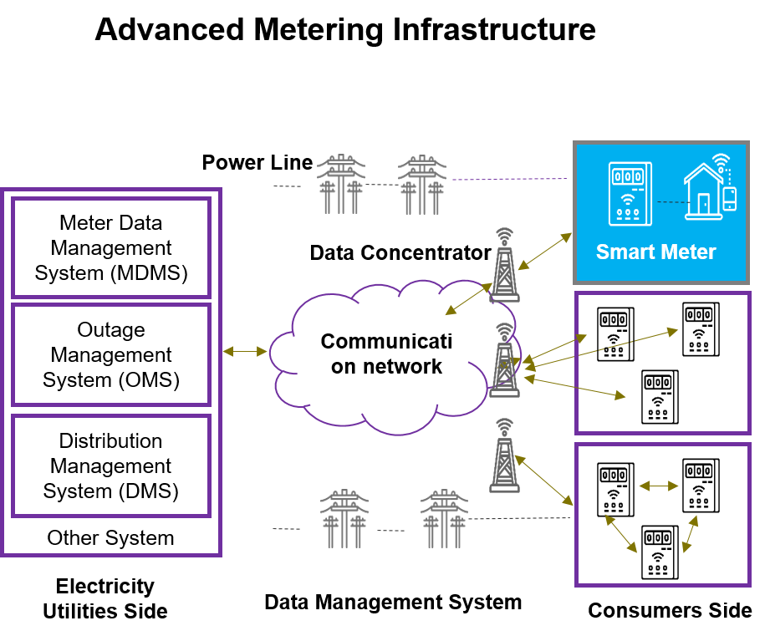
Figure 1: Understanding Advanced Metering Infrastructure (AMI)

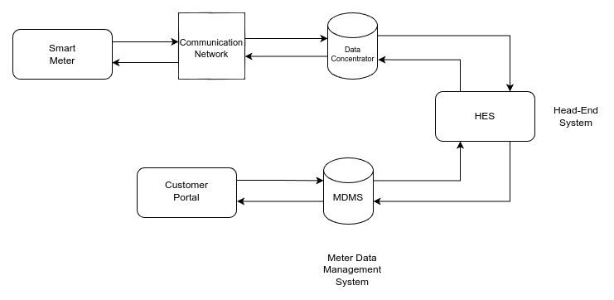
Figure 2: Communication Workflow in an Advanced Metering Infrastructure (AMI) System

Background of Prepaid Metering in Kenya
Kenya, like many developing nations, has increasingly adopted prepaid electricity metering systems as a strategic move to enhance revenue collection, reduce non-technical losses, and empower consumers with greater control over their energy consumption. The state-owned utility, Kenya Power and Lighting Company (KPLC), initiated the rollout of prepaid meters over a decade ago, gradually replacing the traditional post-paid billing system [1]. This transition was driven by several factors, including the need to address issues such as accumulating consumer debts, meter tampering, and the inefficiencies associated with manual meter reading and billing cycles. Prepaid meters operate on a ‘pay-as-you-go’ model, requiring consumers to purchase electricity tokens in advance, which are then loaded onto their meters. This system has proven effective in improving cash flow for the utility and fostering energy conservation among consumers, as they become more conscious of their daily consumption habits.
However, the existing prepaid metering ecosystem in Kenya, while offering significant advantages, is not without its limitations. The primary method of recharging involves consumers purchasing tokens through various channels, predominantly mobile money platforms like M-Pesa, and then manually entering a 20-digit token code into a Customer Interface Unit (CIU) connected to their meter. While M-Pesa has revolutionized financial transactions in Kenya, its integration with the prepaid metering system often remains a semi-manual process. This manual intervention introduces several points of failure and inconvenience, ranging from human error during token entry to delays in token delivery via SMS, and the operational challenges posed by faulty or missing CIUs in many households. These issues frequently lead to unexpected power disconnections, consumer frustration, and increased demand on KPLC’s customer support services.

Evolution of Prepaid Metering Systems
Prepaid metering systems have undergone a significant evolution, driven by the need for more efficient revenue collection, reduced operational costs for utilities, and greater control for consumers over their energy consumption. Understanding this evolution is crucial for contextualizing the proposed IoT-enabled system.

Traditional Prepaid Systems
Early prepaid metering systems were often mechanical or electro-mechanical, relying on physical tokens or smart cards. In these systems, consumers would purchase a physical token or load credit onto a smart card, which then had to be physically inserted into or swiped at the meter to transfer the purchased energy units. While these systems introduced the concept of pre-payment, they were cumbersome, prone to physical damage or loss of tokens/cards, and required consumers to physically visit vending points. They lacked any form of remote communication, making real-time monitoring or remote management impossible.

GSM-Based Prepaid Meters
The introduction of Global System for Mobile Communications (GSM) technology marked a significant leap forward in prepaid metering. GSM-based meters allowed for remote communication, primarily for token delivery and sometimes for basic meter readings. Consumers could purchase electricity tokens via mobile money platforms or other electronic payment channels, and a unique token code would be sent to their mobile phones via SMS. This 20-digit (or similar length) code then had to be manually entered into a Customer Interface Unit (CIU) connected to the meter. This eliminated the need for physical tokens and vending points, offering greater convenience. However, as noted in the problem statement, these systems still suffer from several drawbacks [6]:
- Manual Token Entry: The requirement for manual input of long token codes is a major source of human error, leading to failed recharges and frustration.
- CIU Dependency: The reliance on a functional CIU means that if the CIU is faulty, missing, or lacks power (e.g., during an outage), the consumer cannot recharge their meter.
- SMS Reliability Issues: SMS delivery can be subject to network delays, congestion, or even complete failure, leading to delayed or lost tokens and unexpected power disconnections.
- Limited Bidirectional Communication: While some GSM meters can send basic consumption data, they typically lack the robust two-way communication capabilities necessary for real-time load control, remote diagnostics, or advanced grid management features.
- Lack of Direct Payment Integration: The payment process is often decoupled from the token application process. Consumers pay, receive an SMS, and then manually apply the token, rather than having a seamless, automated recharge.

Early IoT-Based Prototypes and Smart Meters
More recently, the integration of IoT technologies has led to the development of smarter prepaid meters. These systems leverage internet connectivity (Wi-Fi, GPRS, LoRaWAN, NB-IoT) to enable real-time data transmission from the meter to a central server. Many academic prototypes have demonstrated IoT-based prepaid meters capable of:
- Remote Monitoring: Sending consumption data, balance levels, and meter status to a cloud platform for remote viewing.
- Automated Alerts: Notifying users or utilities of low balance or tampering attempts.
- Basic Remote Control: Some prototypes include rudimentary remote connect/disconnect features.
However, a common limitation of many of these early IoT prototypes, especially in the context of developing economies, is the lack of deep integration with local payment ecosystems. While they may support online payments, the automation of the entire recharge process, from payment confirmation to automatic token application without any manual intervention, is often not fully realized. Furthermore, the focus is often on the technical feasibility of IoT connectivity rather than the practical aspects of cost-effectiveness and scalability for mass deployment. Many also do not fully embrace the comprehensive capabilities of AMI, often acting as advanced data loggers rather than interactive grid components [6].

The Role of Mobile Money in Kenya (M-Pesa)
M-Pesa, launched by Safaricom in 2007, has become an indispensable part of Kenya’s financial landscape. It is a mobile phone-based money transfer service, payments, and micro-financing service. Its widespread adoption has transformed how Kenyans conduct financial transactions, from sending money to family members to paying for goods and services, and utility bills. The ubiquity of M-Pesa presents a unique opportunity for integrating payment solutions directly into smart metering systems [5].
Safaricom’s Daraja API is the developer platform that allows businesses and developers to integrate their systems with M-Pesa. It provides various API endpoints for different transaction types, including Customer to Business (C2B) payments (e.g., Lipa na M-Pesa, M-Pesa Express) and Business to Customer (B2C) payments [8]. Leveraging the Daraja API, or a simulation thereof for prototyping, is critical for developing a system that can seamlessly process M-Pesa payments and trigger automated recharges. The ability to receive real-time payment confirmations via the Daraja API’s callback mechanisms is fundamental to achieving the automated, manual-token-entry-free recharge process envisioned by this project.
Existing prepaid meter systems in Kenya often use M-Pesa as a payment channel, but the integration is typically at a superficial level where the payment merely triggers an SMS with a token. The proposed system aims for a deeper integration, where the payment directly communicates with the meter management system (or its simulation) to automatically update the meter’s balance, thus eliminating the need for manual token entry altogether. This level of integration is a key differentiator and a significant improvement over current practice.

Methodology
This chapter details the comprehensive methodology employed for the design, development, and validation of the IoT-enabled automatic recharge system for Kenyan prepaid meters. The approach will be iterative, involving design, development, testing, and refinement phases. The core of the system will revolve around an ESP32 microcontroller, chosen for its integrated Wi-Fi and Bluetooth capabilities, cost-effectiveness, and suitability for IoT applications. The methodology will cover system architecture, hardware components, software design, and integration with simulated M-Pesa Daraja API.

Design and Prototyping of ESP32-Based Prepaid Meter

Circuit Design and Component Assembly
The circuit design for the ESP32-based prepaid meter focuses on integrating essential components that simulate the functionalities of a real-world prepaid meter. The selection of components is driven by their availability, cost-effectiveness, and their ability to demonstrate key features such as load control, visual feedback, and audible alerts. The primary components include a relay for load control, an OLED display for user feedback, a buzzer for audible alerts, LEDs for status indication, and a stable power supply setup.
Relay Module (1-channel, 5V/10A) is crucial for simulating the disconnection and reconnection of the electrical load. This component acts as a switch, controlled by the ESP32, to cut off power when the simulated meter balance reaches zero and to restore it upon successful recharge.
OLED display (e.g., 0.96-inch I2C OLED) is chosen for its low power consumption and clear visual output, providing real-time feedback on the current meter balance, status messages, and recharge notifications.
Buzzer is incorporated to provide audible alerts for critical events, such as low balance warnings or successful recharge confirmations, enhancing the user experience by providing immediate auditory feedback.
LEDs are used as visual indicators, with one LED simulating an active electrical load (turning off when power is disconnected and on when reconnected) and others potentially indicating Wi-Fi connectivity or system status.
Power Supply Module (5V/3.3V) ensures stable power delivery to the ESP32 and all connected peripherals, enabling standalone operation of the prototype.
Initial assembly and testing of the circuit components will be performed on a breadboard using jumper wires.

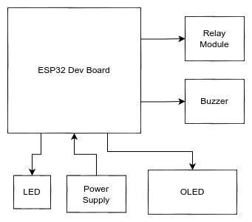
Figure 3: Functional Block Diagram of the ESP32-Based Control System

ESP32 Firmware Development
The ESP32 firmware will be developed using the Arduino IDE, leveraging the ESP-IDF framework for advanced functionalities. Key modules of the firmware will include:
- Wi-Fi Connectivity Module: Responsible for connecting the ESP32 to the internet and maintaining a stable connection to the cloud platform.
- Meter Simulation Logic: This module will manage the simulated meter balance. It will periodically decrement the balance based on a configurable consumption rate (e.g., units per second/minute) and trigger load control actions when the balance reaches zero. It will also handle the reception and application of recharge tokens.
- Load Control Module: Interfacing with the relay module, this module will switch the simulated load (LED) on or off based on the meter balance status.
- Display and Alert Module: Managing the LCD/OLED display to show real-time balance and status messages. It will also control the buzzer and load indicator LED for alerts.
- Cloud Communication Module: Securely sending meter data (current balance, status) to the cloud platform and receiving commands (recharge, remote connect/disconnect) from it. MQTT or HTTPS will be considered for secure and efficient communication.

Development of Cloud Backend and M-Pesa Simulation
This section outlines the development of the cloud backend and M-Pesa Daraja API simulation, which enable automated payments, meter data management, and communication with the ESP32-based meter. The cloud system acts as the core, handling data processing, transactions, and communication protocols

3.2.1 Cloud Backend Design
The cloud backend will be developed using a suitable web framework (e.g., Python with Flask/Django, Node.js with Express) and deployed on a cloud provider (e.g., AWS, Google Cloud, Azure). Its design prioritizes scalability, security, and efficient data handling to support a large number of simulated meters and transactions. The core functionalities include a robust REST API, a secure database, and efficient communication mechanisms.
- API Endpoints: Secure RESTful APIs for the ESP32 to send data and receive commands, and for the M-Pesa Daraja API simulation to send payment notifications.
- Database Management: Storing meter data, user information, transaction logs, and system configurations. A NoSQL database (e.g., MongoDB) or a relational database (e.g., PostgreSQL) will be considered based on scalability and data structure requirements.
- Recharge Processing Logic: Upon receiving a payment confirmation from the M-Pesa Daraja API simulation, this logic will validate the transaction, update the corresponding meter’s balance in the database, and send a recharge command to the ESP32.
- Monitoring and Analytics: Collecting and visualizing meter data for system health monitoring and potential future analytics on consumption patterns.

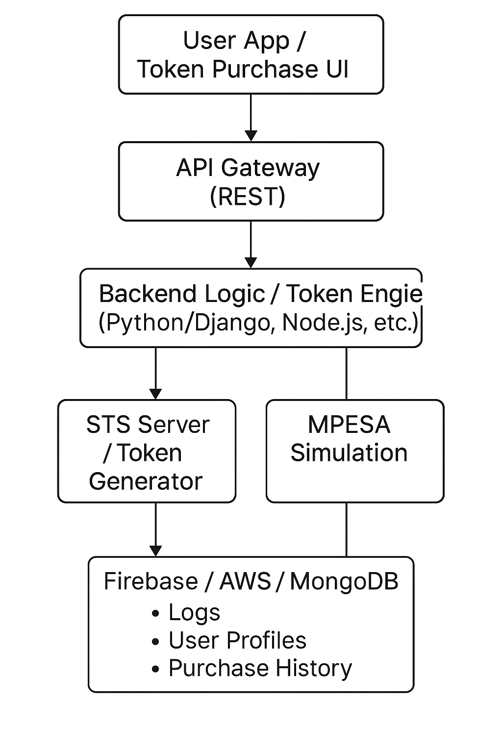
Figure 4: Cloud-Based Token Purchase and M-Pesa Simulation Architecture [8]

3.2.2 M-Pesa Daraja API Simulation
To facilitate comprehensive testing of the automated recharge system without relying on actual financial transactions, a dedicated application will be developed to simulate the M-Pesa Daraja API. This simulation will mimic the essential functionalities of the real Daraja API, focusing on payment initiation and confirmation mechanisms. This approach allows for a controlled and repeatable testing environment, ensuring the robustness of the system’s payment integration logic.
- C2B (Customer to Business) Payments: Simulating a customer initiating a payment to the utility’s M-Pesa till number. The simulation will generate a callback to the cloud platform, mimicking a successful payment notification.
- STK Push (Sim Tool Kit Push): Simulating the initiation of a payment prompt on the customer’s M-Pesa enabled phone, and subsequently sending a payment confirmation to the cloud platform upon successful (simulated) completion.
This simulation will allow for thorough testing of the end-to-end automatic recharge process without relying on actual M-Pesa transactions during the development and testing phases. It will mimic the structure and expected responses of the actual Daraja API to ensure compatibility.

Payment verification and recharge token generation
Upon receiving a simulated payment callback from the M-Pesa Daraja API mock, the cloud backend will initiate the payment verification and recharge token generation process. The payment verification step involves cross-referencing the received transaction details (e.g., amount, sender, transaction ID) with internal records or expected payment parameters to confirm the legitimacy and correctness of the payment. This step is crucial for preventing fraudulent recharges and ensuring that the correct amount has been paid. Once the payment is verified, the system will proceed to recharge token generation.
Although the ESP32-based meter does not use a literal 20-digit token, the concept of a ‘recharge token’ here refers to the command or data packet sent to the ESP32 to update its simulated balance. This command will contain the amount to be added to the meter’s balance and a unique transaction identifier. The backend will then push this ‘recharge token’ (command) to the ESP32 via the established MQTT or HTTPS communication channel, triggering the balance update on the simulated meter. This entire process, from payment initiation to balance update, will be automated, eliminating any manual intervention.

System Validation and Testing
System validation and testing are crucial phases in the development cycle, ensuring that the integrated system functions as intended, meets performance requirements, and adheres to security considerations. This phase will involve a combination of integration testing, performance testing, and basic security testing to verify the end-to-end functionality and robustness of the IoT-enabled automatic recharge system.

Integration Testing
Integration testing will focus on verifying the seamless communication and interaction between the various components of the system. This type of testing is essential to identify and resolve issues that arise when different modules are combined, ensuring that data flows correctly and functionalities are triggered as expected across the entire architecture.
ESP32 ↔ Cloud ↔ M-Pesa simulation communication
This sub-section of integration testing will specifically validate the communication pathways and data exchange between the ESP32-based simulated meter, the Cloud Backend, and the M-Pesa Daraja API simulation. Tests will be designed to confirm that:
- The ESP32 can reliably connect to the cloud backend via Wi-Fi and MQTT/HTTPS.
- Meter data (e.g., balance updates, status) is accurately transmitted from the ESP32 to the cloud.
- The cloud backend correctly receives and processes payment notifications from the M-Pesa Daraja API simulation.
- Recharge commands and other control signals are successfully sent from the cloud backend to the ESP32.
- The M-Pesa Daraja API simulation accurately mimics real-world payment scenarios and sends appropriate callbacks to the cloud backend.
Test cases will involve simulating various scenarios, such as successful payments, failed payments, network interruptions, and delayed responses, to ensure the system’s resilience and error-handling capabilities across all communication links.
Testing automated recharge flow end-to-end
This critical aspect of integration testing will involve testing the automated recharge flow end-to-end. The objective is to verify that a simulated payment initiated through the M-Pesa Daraja API simulation correctly triggers a balance update on the ESP32-based meter without any manual intervention. Test scenarios will cover:
- Initiating a simulated payment via the M-Pesa Daraja API simulation.
- Verifying that the cloud backend receives and processes the payment callback.
- Confirming that the cloud backend sends the appropriate recharge command to the ESP32.
- Observing that the ESP32 updates its simulated balance and reflects the change on the OLED display.
- Validating that the load control mechanism (relay) correctly reconnects power if it was previously disconnected due to zero balance.
This end-to-end testing will ensure that the entire chain of events, from payment initiation to meter recharge, functions autonomously and reliably, fulfilling the core objective of the project.

Performance and Security Testing

- Token Application Speed – Measures how quickly the meter updates after payment confirmation, ensuring minimal delay in electricity restoration by testing under different network and processing conditions.
- Load Cut-Off/Reconnect Accuracy – Assesses how precisely and reliably the meter disconnects power at zero balance and reconnects it after recharge, including edge-case testing for low balances and quick recharges.
- Basic Data Encryption & HTTPS Validation – Verifies secure communication via TLS/SSL between system components, ensures server certificate validation by the ESP32, and checks authentication enforcement on API endpoints.

System Flow Diagram
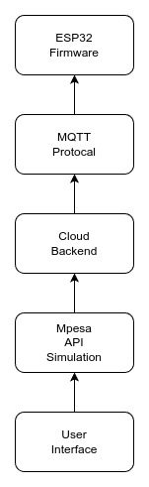
The following diagram illustrates the overall system flow, from the user’s interaction with the M-Pesa API simulation to the final output from the ESP32-based meter.
Figure 5: Block Diagram of the ESP32-Based Smart Metering System

Expected Outcomes and Contributions
This research project is anticipated to yield several significant outcomes and make valuable contributions to the field of IoT, smart metering, and energy management in Kenya. The successful completion of this project will demonstrate the feasibility and benefits of an automated prepaid metering system, paving the way for future advancements and deployments.
Upon the successful completion of this project, the following outcomes are expected:
- A Functional Prototype of an IoT-Enabled Automatic Recharge System: The primary outcome will be a working hardware and software prototype that demonstrates the end-to-end functionality of the proposed system. This prototype will include an ESP32-based simulated meter, a cloud-based backend, and a simulated M-Pesa Daraja API integration, all communicating seamlessly to facilitate automated recharges.
- Validated System Architecture and Design: The project will result in a thoroughly tested and validated system architecture that can serve as a blueprint for future development and commercialization. This includes detailed designs for hardware integration, firmware logic, cloud infrastructure, and API interactions.
- Proof of Concept for Seamless M-Pesa Integration: The project will provide a concrete proof of concept for integrating M-Pesa payments directly with a smart metering system to trigger automated recharges, eliminating the need for manual token entry. This will demonstrate a significant improvement over current semi-manual process.
- Demonstration of Real-time Balance Monitoring and Load Control: The prototype will effectively showcase the ability to monitor meter balance in real-time and perform remote load control (power disconnection/reconnection) based on predefined thresholds, leveraging AMI principles.
- Comprehensive Documentation: A detailed research proposal and a final project report will be produced, outlining the problem, literature review, methodology, design, implementation details, testing results, and conclusions. This documentation will be a valuable resource for future research and development in this domain.

Contributions to Knowledge and Practice
This research is expected to make the following contributions:
- Addressing a Critical Gap in Kenyan Prepaid Metering: By focusing on the specific challenges faced by Kenyan consumers (manual token entry, CIU issues, M-Pesa integration), this project directly addresses a significant gap in the existing prepaid metering landscape. It offers a practical solution to enhance user experience and operational efficiency.
- Advancing IoT Applications in Energy Management: The project will contribute to the growing body of knowledge on applying IoT technologies for smart energy management, particularly in the context of developing countries. It will showcase how readily available and cost-effective hardware (ESP32) can be leveraged for complex smart grid functionalities.
- Demonstrating Practical AMI Implementation: While a prototype, the system will practically demonstrate key principles of Advanced Metering Infrastructure, such as two-way communication and remote control, in a tangible and accessible manner. This can serve as an educational tool and a stepping stone for broader AMI adoption.
- Promoting Digital Transformation in the Energy Sector: By proposing a fully automated and digitally integrated recharge system, the project supports the broader agenda of digital transformation within Kenya’s energy sector. It highlights how technology can improve service delivery, reduce operational costs, and enhance customer satisfaction.
- Foundation for Future Research and Development: The developed prototype and comprehensive documentation will serve as a strong foundation for future research. This could include exploring advanced features like predictive analytics for consumption, integration with renewable energy sources, enhanced security measures, and scaling the solution for commercial deployment.
- Cost-Effective Solution Design: The emphasis on using affordable components like the ESP32 demonstrates a viable path towards developing cost-effective smart metering solutions that are suitable for mass deployment in emerging markets, where budget constraints are often a significant factor.

Significance of the Study
This research holds significant importance for various stakeholders within the Kenyan energy sector and beyond. Its findings and the developed prototype are poised to contribute meaningfully to both academic understanding and practical application.
                - For Consumers
For the end-users of electricity, the proposed system offers a substantial improvement in convenience and reliability. The elimination of manual token entry means an end to the frustration of incorrect inputs and the inconvenience of searching for a functional CIU. Automated recharges will significantly reduce instances of unexpected power disconnections due to forgotten top-ups or delayed token delivery, ensuring a more consistent and reliable electricity supply. This leads to an improved overall customer experience, reducing stress and enhancing the quality of life, particularly in households where electricity is critical for daily activities, education, and small businesses.
                - For Kenya Power and Lighting Company (KPLC)
KPLC stands to benefit significantly from the adoption of such a system. Firstly, it will lead to enhanced operational efficiency. By automating the recharge process, the need for customer support related to token entry errors, CIU issues, and SMS delays will drastically decrease, freeing up resources for other critical operations. Secondly, the system will contribute to improved revenue assurance. Automated and seamless recharges can lead to more consistent and timely payments, reducing instances of credit depletion and subsequent non-payment. Thirdly, the integration with AMI principles will provide KPLC with more granular and real-time data on consumption patterns, enabling better load forecasting, demand-side management, and more efficient grid planning. This can also aid in quicker identification and resolution of outages and potentially reduce non-technical losses by providing better oversight of meter status.
                - For the Energy Sector and National Development
At a broader level, this research contributes to the modernization of Kenya’s energy infrastructure. By demonstrating a practical and cost-effective application of IoT and AMI, it supports the national agenda for digital transformation and the development of smart cities. A more efficient and reliable electricity supply is fundamental to economic growth, supporting industries, businesses, and households. The project also serves as a model for how local technological innovation, leveraging prevalent mobile payment systems, can address unique challenges in developing economies. It can inspire further research and development in smart grid technologies tailored to the African context, fostering local expertise and reducing reliance on imported solutions.
                - For Academia and Future Research
Academically, this study provides a valuable case study on the practical implementation of IoT and AMI in a real-world utility context. It contributes to the body of knowledge by detailing a specific solution that integrates hardware, software, and payment gateway simulations to solve a pertinent problem. The methodology and findings can serve as a reference for students and researchers interested in smart metering, IoT applications, embedded systems, and mobile payment integration. Furthermore, the identified limitations and future work suggestions will open avenues for subsequent research, encouraging continuous innovation in the field.

References

[1] | F. M. Mwaura, " Adopting electricity prepayment billing system to reduce non-technical energy losses in Uganda: Lessons from Rwanda," Energy Policy, vol. 44, pp. 331-336, 2012.
[2] | A. Ikpehai, B. Adebisi and K. M. Rabie, "Broadband PLC for Clustered Advanced Metering Infrastructure(AMI) Architecture," Energies, vol. 9, no. 7, p. Article 569, 2016.
[3] | V. C. Gungor, D. Sahin, T. Kocak, S. Ergüt, C. Buccella, C. Cecati and G. P. Hancke, "A Survey on Smart Grid Potential Applications and Communication Requirements," IEEE Transactions on Industrial Informatics, vol. 9, no. 1, pp. 28-42, 2013.
[4] | P. Raj and A. Raman, The Internet of Things: Enabling Technologies, Platforms, and Use Cases, Boca Raton,Florida, USA: CRC Press, 2020.
[5] | W. Jack and T. Suri, "Mobile money: The economics of M-Pesa," National Bureau of Economic Research(Working Paper No 16721), Massachusetts, 2011.
[6] | S. S. S. R. Depuru, L. Wang and V. Devabhaktuni, "Smart meters for power grid: Challenges, issues, advantages and status," Renewable & Sustainable Energy Reviews, vol. 15, no. 6, pp. 2736- 2742, 2011.
[7] | C. O. Munda and A. Oduor, "Smart Grid Initiatives in Kenya: A Review," International Journal of Engineering Research & Technology (IJERT), vol. 6, no. 12, pp. 1-4, 2017.
[8] | S. PLC, "Daraja API Documentation," 2023. [Online]. Available: https://developer.safaricom.co.ke/daraja/apis/post/safaricom-sandbox.

